SR UNIVERSITY
AI ASSISTED CODING
MANADI SWATHI
2503A51L12
BATCH-19

Using AI to Improve Code Quality and Readability
Lab Objectives
- Use AI for automated code review and quality enhancement.
- Identify and fix syntax, logical, performance, and security issues in Python code.
- Improve readability and maintainability through structured refactoring and comments.
- Apply prompt engineering for targeted improvements.
- Evaluate AI-generated suggestions against PEP 8 standards and software engineering best practices

TASK 1: Syntax and Error Detection
Identify and fix syntax, indentation, and variable errors in the given script.
# buggy_code_task1.py
def add_numbers(a, b)
result = a + b
return reslt
print(add_numbers(10 20))
Expected Output:
- Corrected code with proper syntax (: after function, fixed variable name, corrected function call).
- AI should explain what was fixed.
Before Detection:
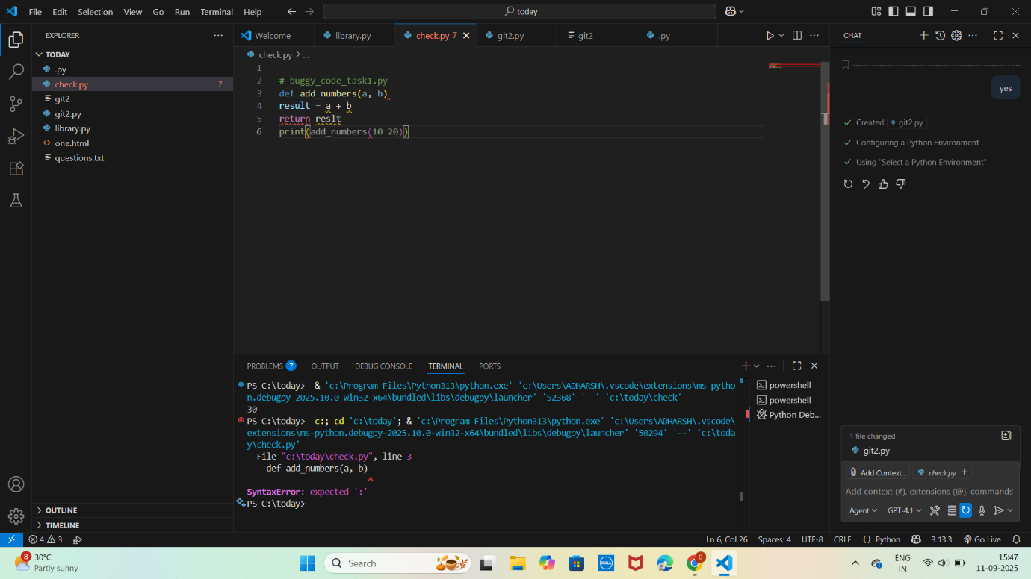
After Detection:
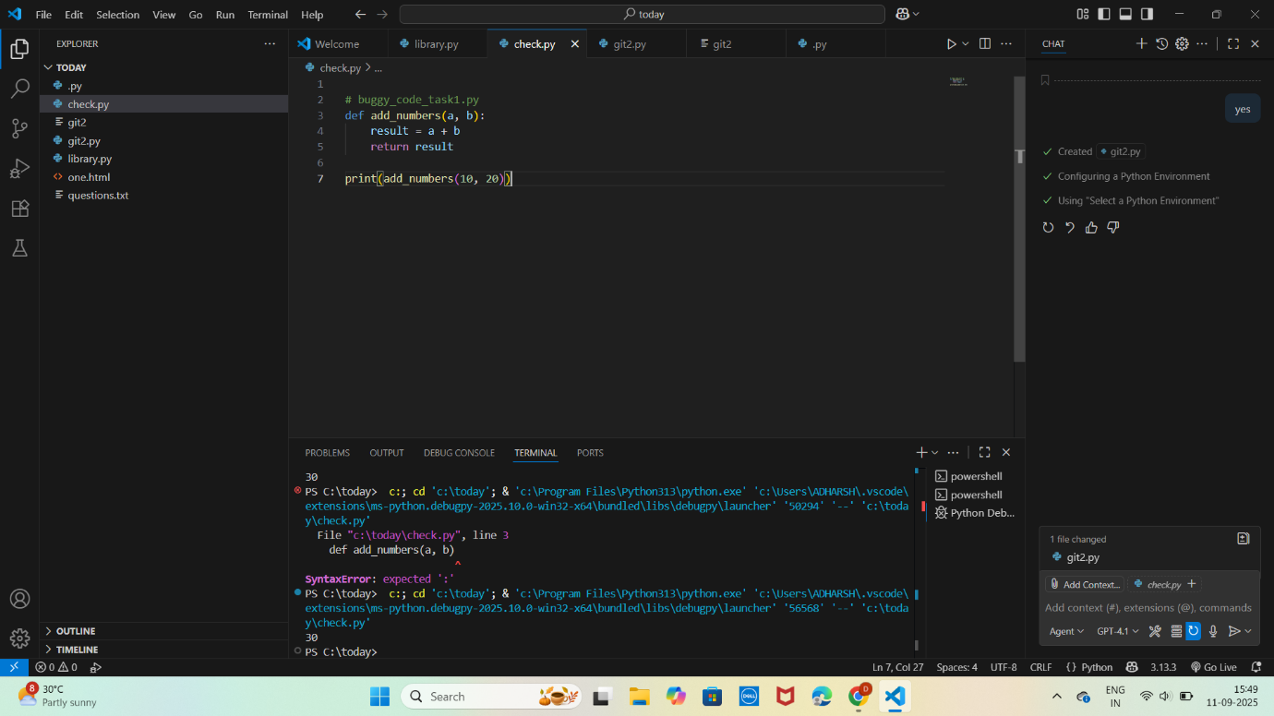
Task 2: Logical and Performance Issue Review
Optimize inefficient logic while keeping the result correct.
# buggy_code_task2.py
def find_duplicates(nums):
duplicates = []
for i in range(len(nums)):
for j in range(len(nums)):
if i != j and nums[i] == nums[j] and nums[i] not in duplicates:
duplicates.append(nums[i])
return duplicates
numbers = [1,2,3,2,4,5,1,6,1,2]
print(find_duplicates(numbers))
Expected Output:
More efficient duplicate detection (e.g., using sets).
AI should explain the optimization.
Before detection:
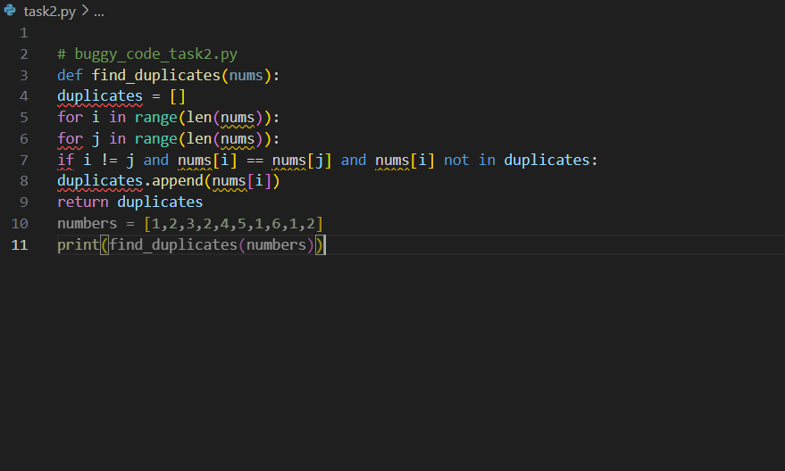
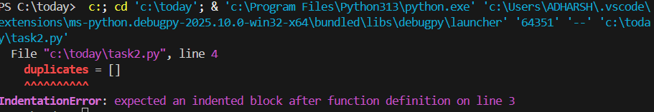
After Detection:
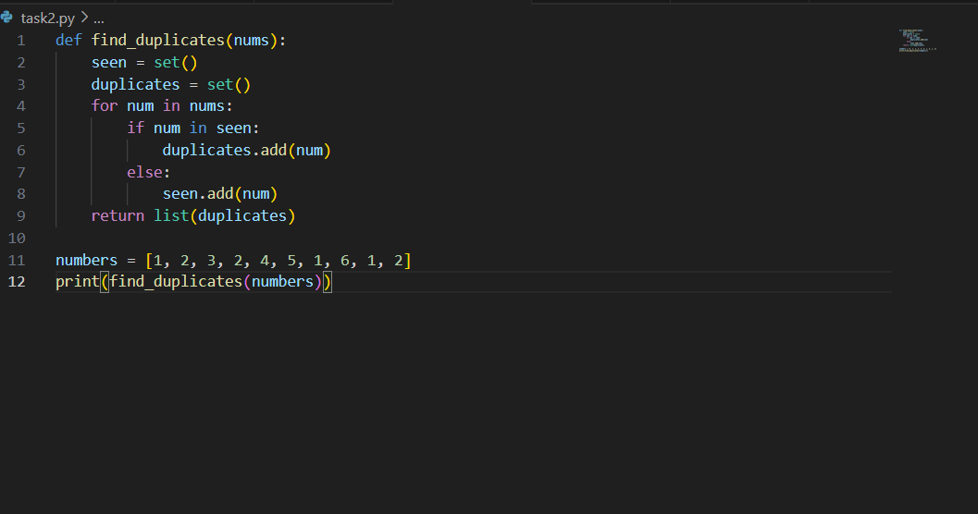
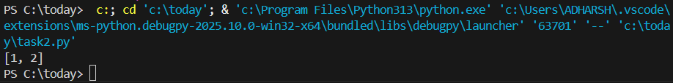
Task 3: Code Refactoring for Readability
Refactor messy code into clean, PEP 8–compliant, well-structured code.
# buggy_code_task3.py
def c(n):
x=1
for i in range(1,n+1):
x=x*i
return x
print(c(5))
Expected Output:
Function renamed to calculate_factorial.
Proper indentation, variable naming, docstrings, and formatting.
AI should provide a more readable version.
Before Detection:
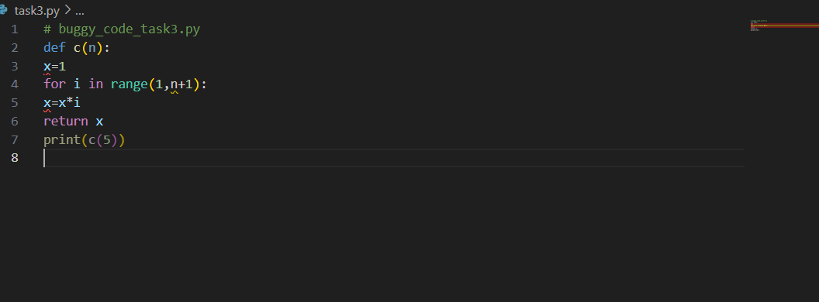
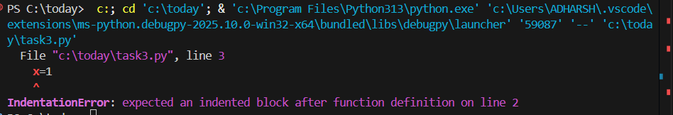
After Detection:
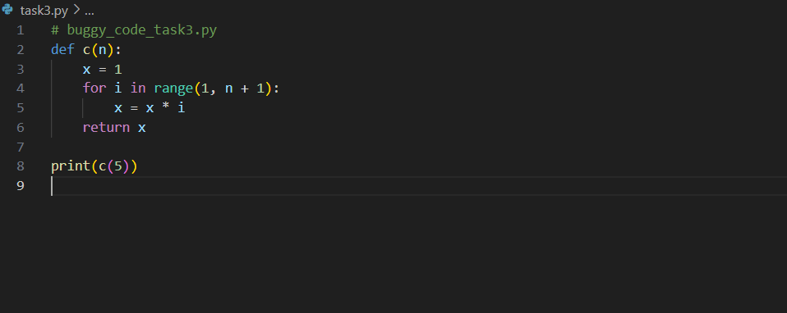
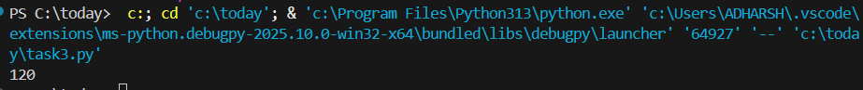
Task 4: Security and Error Handling Enhancement
Add security practices and exception handling to the code.
# buggy_code_task4.py
import sqlite3
def get_user_data(user_id):
conn = sqlite3.connect("users.db")
cursor = conn.cursor()
query = f"SELECT * FROM users WHERE id = {user_id};" # Potential SQL injection risk
cursor.execute(query)
result = cursor.fetchall()
conn.close()
return result
user_input = input("Enter user ID: ")
print(get_user_data(user_input))
Expected Output:
Safe query using parameterized SQL (? placeholders).
Try-except block for database errors.
Input validation before query execution.
Before Detection:
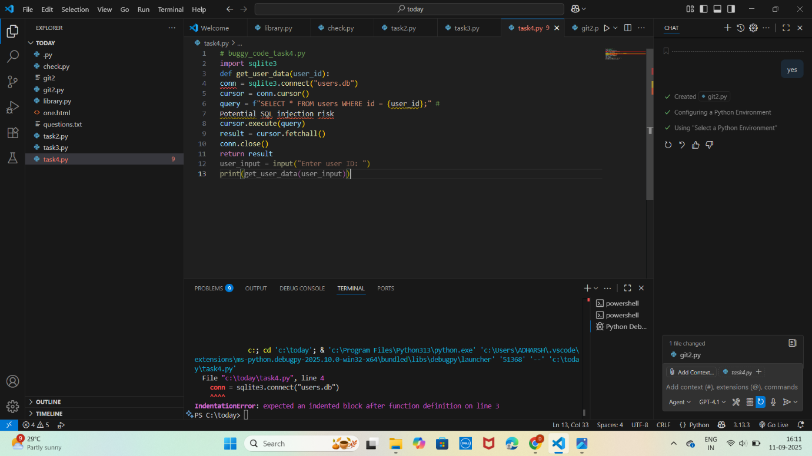
After Detection:
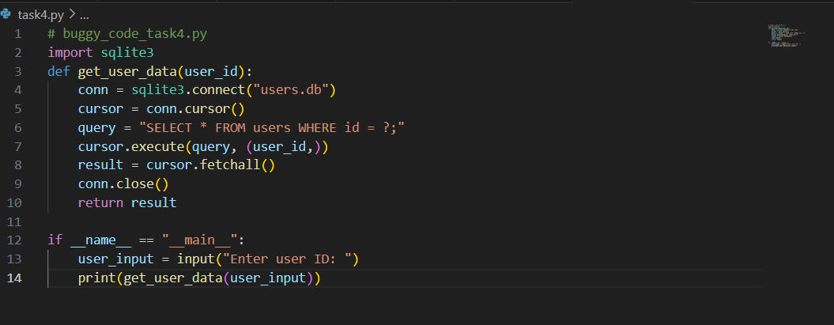
Task 5: Automated Code Review Report Generation
Generate a review report for this messy code.
# buggy_code_task5.py
def calc(x,y,z):
if z=="add":
return x+y
elif z=="sub": return x-y
elif z=="mul":
return x*y
elif z=="div":
return x/y
else: print("wrong")

print(calc(10,5,"add"))
print(calc(10,0,"div"))

Expected Output:
AI-generated review report should mention:
Missing docstrings
Inconsistent formatting (indentation, inline return)
Missing error handling for division by zero
Non-descriptive function/variable names
Suggestions for readability and PEP 8 compliance
Before Detection:

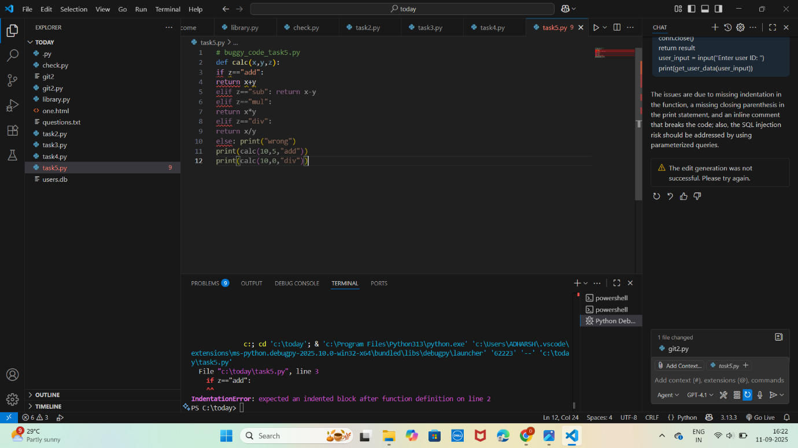
After Detection:
